St. John’s Lutheran Church

Covington, OH
Church Office (937) 473-2170
Pastor’s Cell (865) 363-9676

18th Sunday after Pentecost

SERVICE OF THE WORD
September 27, 2026

+ GATHERING+

PRELUDE & PREPARE FOR WORSHIP
As we listen to the prelude music, we are invited to focus our attention on God and God’s kingdom, praying silently or engaging in quiet meditation.

WELCOME & ANNOUNCEMENTS
(*Stand as Able)

*CONFESSION & FORGIVENESS
All may make the sign of the cross, the sign marked at baptism, as the presiding minister begins.
Blessed be the holy Trinity, ☩ one God, who pours love into our hearts and healing upon the earth.
Amen.
Confident that God justifies us by grace through faith,
let us confess our sin.
Silence is kept for reflection.
Compassionate God,
we confess that we struggle to embody your goodness
in the world and in our own hearts.
Creation groans from overuse.
Jealousy and bitterness strain our relationships.
Indifference keeps us from seeking justice.
Divisions disrupt your call to show genuine love
to others. Turn our hearts back to you. Restore our world and reconcile us to one another. Renew us to live as your holy people, following the way of Jesus Christ.
Amen.
Hear this good news:
We have peace with God through ☩ Jesus Christ,
in whom there is no condemnation,
but only forgiveness and the promise of eternal life.
Receive freely this healing gift of grace.
Amen.
*GATHERING 818 red book

*GREETING
The grace of our Lord Jesus Christ, the love of God, and the communion of the Holy Spirit be with you all.
And also with you.

*PRAYER OF THE DAY
Let us pray
God of love, giver of life, you know our frailties and failings. Give us your grace to overcome them, keep us from those things that harm us, and guide us in the way of salvation, through Jesus Christ, our Savior and Lord.
Amen.

PRAYER FOR THE QUILTS Norma Colby

LWR PRAYER FOR BLESSING OF THE QUILTS (See Insert)

+ WORD+
CHILDREN’S SERMON

FIRST LESSON Ezekiel 18:1-4, 25-32
¹ The word of the Lord came to me: ² What do you mean by repeating this proverb concerning the land of Israel, “The parents have eaten sour grapes, and the children’s teeth are set on edge”? ³ As I live, says the Lord God, this proverb shall no more be used by you in Israel. ⁴ Know that all lives are mine; the life of the parent as well as the life of the child is mine: it is only the person who sins who shall die.
²⁵ Yet you say, “The way of the Lord is unfair.” Hear now, O house of Israel: Is my way unfair? Is it not your ways that are unfair? ²⁶ When the righteous turn away from their righteousness and commit iniquity, they shall die for it; for the iniquity that they have committed, they shall die. ²⁷ Again, when the wicked turn away from the wickedness they have committed and do what is lawful and right, they shall save their life. ²⁸ Because they considered and turned away from all the transgressions that they had committed, they shall surely live; they shall not die. ²⁹ Yet the house of Israel says, “The way of the Lord is unfair.” O house of Israel, are my ways unfair? Is it not your ways that are unfair?
³⁰ Therefore I will judge you, O house of Israel, all of you according to your ways, says the Lord God. Repent and turn from all your transgressions; otherwise iniquity will be your ruin. ³¹ Cast away from you all the transgressions that you have committed against me, and get yourselves a new heart and a new spirit! Why will you die, O house of Israel? ³² For I have no pleasure in the death of anyone, says the Lord God. Turn, then, and live.
Word of the Lord. Thanks be to God.

PSALM Psalm 25:1-9
The Psalm may be read responsively, with the congregation reading the bolded lines.
¹ To you, O Lord,
I lift up my soul.
² My God, I put my trust in you; let me not be put to shame,
nor let my enemies triumph over me.
³ Let none who look to you be put to shame;
rather let those be put to shame who are treacherous.
⁴ Show me your ways, O Lord,
and teach me your paths.
⁵ Lead me in your truth and teach me,
for you are the God of my salvation; in you have I trusted all the day long.
⁶ Remember, O Lord, your compassion and love,
for they are from everlasting.
⁷ Remember not the sins of my youth and my transgressions;
remember me according to your steadfast love and for the sake of your goodness, O Lord.
⁸ You are gracious and upright, O Lord;
therefore you teach sinners in your way.
⁹ You lead the lowly in justice
and teach the lowly your way.

SECOND LESSON Philippians 2:1-13
¹ If, then, there is any comfort in Christ, any consolation from love, any partnership in the Spirit, any tender affection and sympathy, ² make my joy complete: be of the same mind, having the same love, being in full accord and of one mind. ³ Do nothing from selfish ambition or empty conceit, but in humility regard others as better than yourselves. ⁴ Let each of you look not to your own interests but to the interests of others. ⁵ Let the same mind be in you that was in Christ Jesus,
⁶ who, though he existed in the form of God,
did not regard equality with God
as something to be grasped,
⁷ but emptied himself,
taking the form of a slave,
assuming human likeness.
And being found in appearance as a human,
⁸ he humbled himself
and became obedient to the point of death—
even death on a cross.
⁹ Therefore God exalted him even more highly
and gave him the name
that is above every other name,
¹⁰ so that at the name given to Jesus
every knee should bend,
in heaven and on earth and under the earth,
¹¹ and every tongue should confess
that Jesus Christ is Lord,
to the glory of God the Father.
¹² Therefore, my beloved, just as you have always obeyed me, not only in my presence but much more now in my absence, work on your own salvation with fear and trembling, ¹³ for it is God who is at work in you, enabling you both to will and to work for his good pleasure.
Word of the Lord. Thanks be to God.

*GOSPEL ACCLAMATION
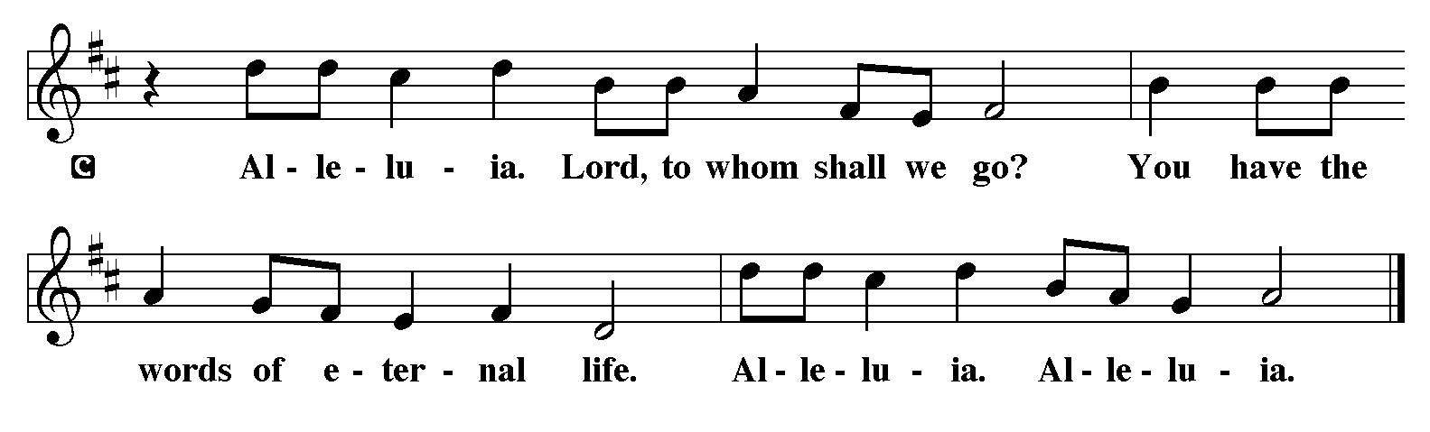

*GOSPEL ANNOUNCEMENT
*The Holy Gospel, according to St. Matthew the 21st Chapter.
Glory to you, O Lord.

READING OF THE GOSPEL Matthew 21:23-32
²³ When [Jesus] entered the temple, the chief priests and the elders of the people came to him as he was teaching and said, “By what authority are you doing these things, and who gave you this authority?” ²⁴ Jesus said to them, “I will also ask you one question; if you tell me the answer, then I will also tell you by what authority I do these things. ²⁵ Did the baptism of John come from heaven, or was it of human origin?” And they argued with one another, “If we say, ‘From heaven,’ he will say to us, ‘Why, then, did you not believe him?’ ²⁶ But if we say, ‘Of human origin,’ we are afraid of the crowd, for all regard John as a prophet.” ²⁷ So they answered Jesus, “We do not know.” And he said to them, “Neither will I tell you by what authority I am doing these things.
²⁸ “What do you think? A man had two sons; he went to the first and said, ‘Son, go and work in the vineyard today.’ ²⁹ He answered, ‘I will not,’ but later he changed his mind and went. ³⁰ The father went to the second and said the same, and he answered, ‘I go, sir,’ but he did not go. ³¹ Which of the two did the will of his father?” They said, “The first.” Jesus said to them, “Truly I tell you, the tax collectors and the prostitutes are going into the kingdom of God ahead of you. ³² For John came to you in the way of righteousness, and you did not believe him, but the tax collectors and the prostitutes believed him, and even after you saw it you did not change your minds and believe him.”
The gospel of the Lord. Praise to you, O Christ.

SERMON “A Gospel of Living Righteousness”
Matthew 21:23-32

*HYMN OF THE DAY 614 red book
*APOSTLES’ CREED
God has made us his people through Our Baptism into Christ. Living together in trust and hope, we confess our faith.
I believe in God, the Father almighty, creator of heaven and earth.
I believe in Jesus Christ, God’s only Son, our Lord, who was conceived by the Holy Spirit, born of the virgin Mary, suffered under Pontius Pilate, was crucified, died, and was buried; he descended to the dead. On the third day he rose again; he ascended into heaven, he is seated at the right hand of the Father, and he will come to judge the living and the dead.

I believe in the Holy Spirit, the holy catholic church, the communion of saints, the forgiveness of sins, the resurrection
of the body, and the life everlasting. Amen.

*PRAYERS OF INTERCESSION
Here we lift up prayers for the church, the world, and all those in need. The congregation may respond with the bolded lines.
Reminded of God’s gracious and abundant love, we offer our prayers, confident that God hears us.
A brief silence.
Center your church in humility as we strive to follow in your way. Help us listen to the cries of those who have been unfairly hurt by the church and dare to name difficult truths. Show all your love. Hear us, O God.
Your mercy is great.
You call us to care for your creation. Lead us into your promise of a better world through sustainable practices and respect for your handiwork. Hear us, O God.
Your mercy is great.
Inspire all in positions of authority to act honorably. Remind them of their call to use their authority for the sake of the common good. Give them the gift of humility. Hear us, O God.
Your mercy is great.
Comfort those who come before you in fear and trembling. Calm troubled hearts with your forgiveness. Help all those in need. Grant us your salvation. Hear us, O God.
Your mercy is great.
Change this congregation’s heart when we say no to your call. Open us to courageous learning and service in our community, especially in new or challenging places. Hear us, O God.
Your mercy is great.
Here other intercessions may be offered.
Your steadfast love holds all the saints who have finished their work and are at rest. As we grieve, remind us of your mercy so we may also give thanks. Hear us, O God.
Your mercy is great.
Grant the prayers we have offered, what we have forgotten to ask, and whatever else you see that we need. We ask this in Jesus’ name.
Amen.

*SHARING OF THE PEACE
The peace of the Lord be with you always.
And also with you.
(Greet one another saying, “Peace be with you.”)

SPECIAL MUSIC “We Come to You For Healing, Lord”

+ THANKSGIVING+

*OFFERTORY 884 red book
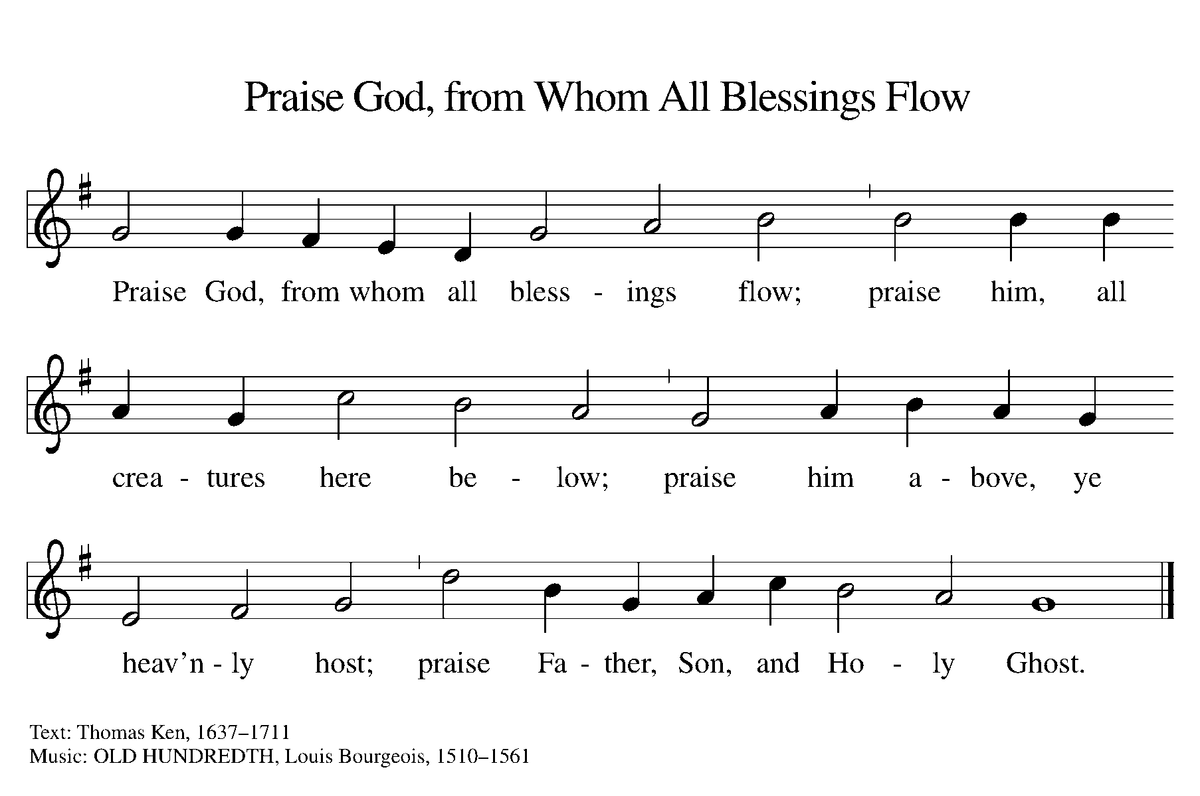

*THANKSGIVING FOR THE WORD
Let us pray.
O God of justice and love, we give thanks to you that you illumine our way through life with the words of your Son. Give us the light we need, awaken us to the needs of others, and at the end bring all the world to your feast; through Jesus Christ, our Savior and Lord, to whom, with you and the Holy Spirit, be honor and glory forever. Amen.

*LORD’S PRAYER

+ SENDING+
*BLESSING
The God of love
draw you into full accord and one mind,
in the body of Christ Jesus.
Amen.
The God of hope
grant you strength and joy in all circumstances
through the interceding of the Spirit.
Amen.
The God of grace
☩ bless you now and forever.
Amen.

*SENDING SONG 545 red book

ORGAN MEDITATION

*DISMISSAL
Go out in joy. Be led forth in peace.
Thanks be to God.

*POSTLUDE

PRAYER LIST FOR September 27th
HOSPITALIZED
RECOVERING AT HOME
Delbert Kiehl Betty Hollopeter Freda Smith Erica Hollopeter
Keith Fletcher Patrick Besecker Jerry Besecker John Mutzner
OTHER PRAYER CONCERNS
Leon Hollopeter Keith Fletcher Kathy Short Dennis Schmidt
Sally Griffin Erica Hollopeter Harold Roeth Dianne Schmidt
Judy Fletcher Luella Roeth Gloria & Dick Hahn
Pastor Rachel Patterson Rick Short
IN EXTENDED CARE
Dale & Marge McKinney (Story Point)
FRIENDS & RELATIVES OF MEMBERS
Alvin Bollheimer at StoryPoint (brother of Freda Smith)
Baby Caspian- ongoing serious health issues (friend of Emily Kaufman)
Owen Gauntt (friend of Dawn Flory)
Paula Hahn (daughter-in-law of Richard & Gloria Hahn)
Dale Heintz
Mary Lou Hitchcock (Keith Fletcher’s sister)
Terry Hoke (Covington school staff member)
Gary Holfinger (son of Opal Holfinger)
Ethan Kendig (son of Covington teacher)
Kariyah King (Piqua H.S. student w/brain cancer)
John & Carolyn Kleppinger (friends of Jim Larson)
Kennedy Kraft (granddaughter of Mary Ann Francis)
Jon Lenehan (brother in law of Leon & Betty Hollopeter)
Mike McCoy (friend of Briana King)
Jim Schmidt
Pastor Jonathan Schriber
Kenton Stacy (grandson of Wanda Stacy)
Harley Stephan (cousin of Brooks King)
Beverly Zimmer (mother of Connie Adams)
FAMILY & FRIENDS IN THE ARMED FORCES
Jaiden C Flory - US Air Force – Little Rock AFB
Faith Duckett- Army National Guard Staff Sergeant C-Battery 1-134 Field Artillery
Regiment, Marysville, OH (niece of Brooks and Briana King)
Fletcher Metz- Army- Caisson Detachment, 1st Battalion,
3rd U.S. Infantry Regiment, “The Old Guard”, United States Army, Ft. Myer, VA
Brandon Moyer – Navy, Naval Air Station, Fallon NV
Jon Osterman- Army

Financial Stewardship Gifts

Weekly Needs Rec’d 9/20 YTD Rec’d
$4,599.00 (Current) TBA TBA
$ 245.00 (Benev.) TBA TBA

Last Sunday Attendance: Worship Service: 38

SCHEDULE OF MEETINGS/ ACTIVITIES THIS COMING WEEK:
MINISTRY FAIR IN BACK OF CHURCH
Today - 9:00 a.m. Adult Ed (Lectionary Based)
9:00 a.m. Choir Practice
10:00 a.m. Worship Service
Sunday - 9:00 a.m. Adult Ed (Bible Study)
9:00 a.m. Youth Sunday School
9:00 a.m. Choir Practice
10:00 a.m. Holy Communion

Ministers serving in the worship service today:
Ministers The baptized of St. John’s
Pastor Pastor Rachel Patterson
Organist Kristin Gephart
Choir Director Norma Colby
Ushers Open
Altar Guild Karen Stangel & Nancy Armstrong
Assisting Minister Darla Brumfield
Lector Rachel Larson
Nursery Brooks & Briana King
Tellers Betty Hollopeter & Sally Griffin

Please remember that you will serve at next Sunday’s 10:00 a.m. Worship:
Assisting Minister- Briana King, Lector- Holly Gephart,
Nursery- Open-Unattended, Ushers- Larsons, Altar Guild- Holly Gephart & Gwen Shoemaker, Tellers-Betty Hollopeter & Betty McKibben.

Floral Offering
Karen Gearhardt in loving memory of Marion Smith.
CD recordings of this service are available.

